CN LAB FILE
Name – Mohit Ranjan
Roll – 23103095
GRP – G1

Create a scenario where four different departments (IT, HR, Sales, Finance) of different local area networks are directly connected through a central router. Each department has at least 4 end systems. Each topology has at least one router. Do the following for the given scenario:
a) Provide the Static IP Address to every end device available in the network.
b) Label each and every interface with their IP Address.
c) Use a different topology for each department
d) Configure RIP routing.
e) Show the data transmission between each department
f) Also, explain the overall topology of the network.

Solution:

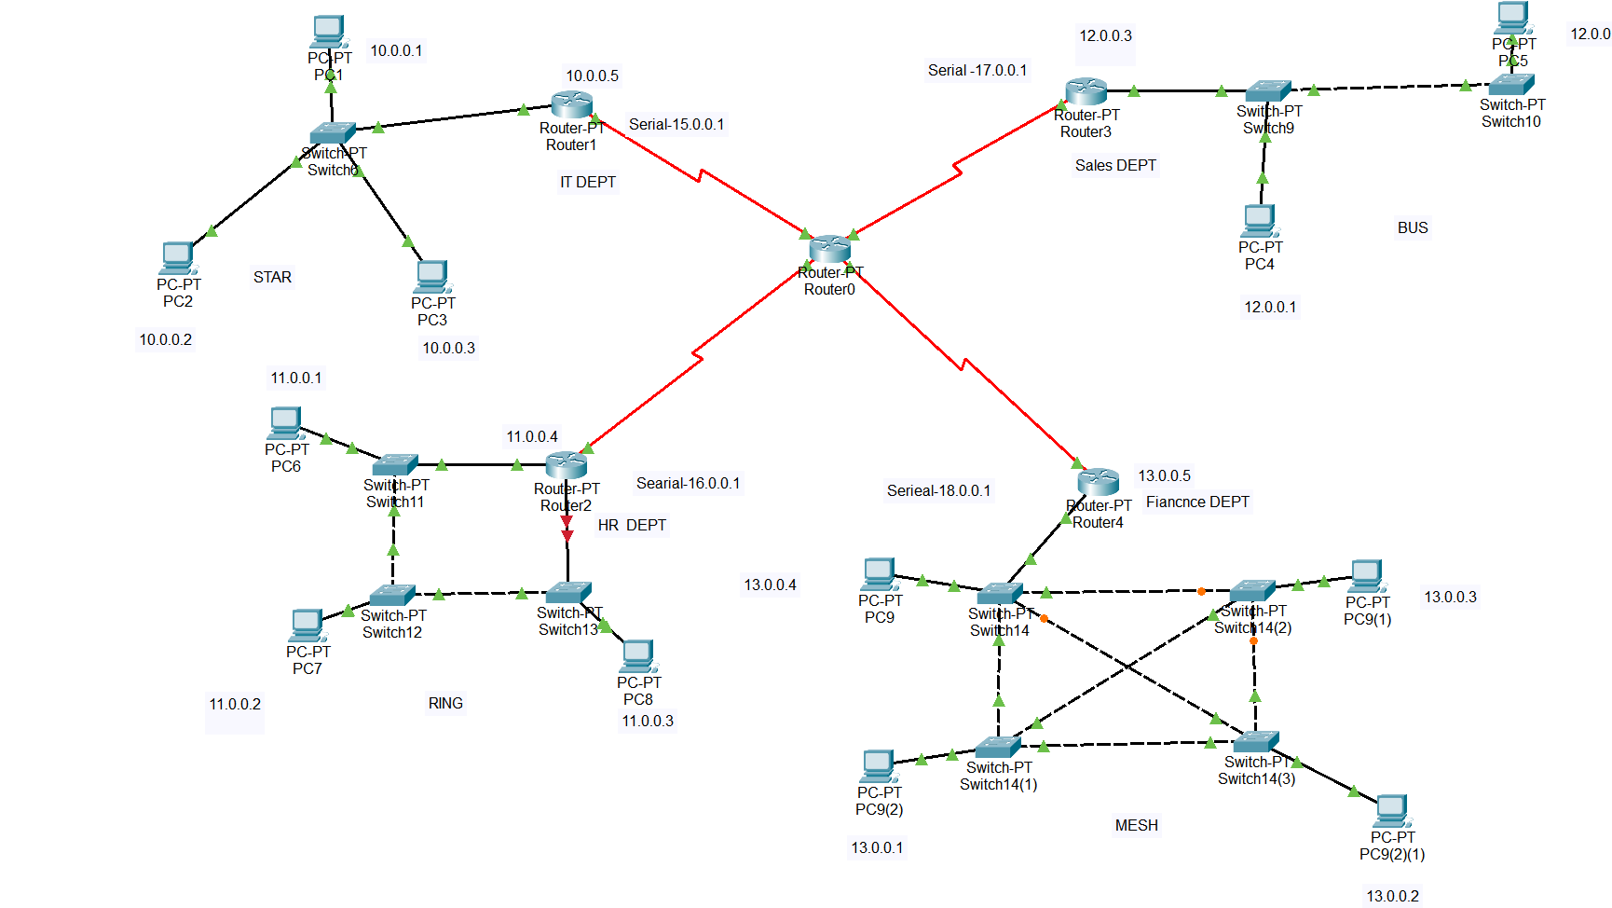
FIG – DYNAMIC ROUTING USING RIP

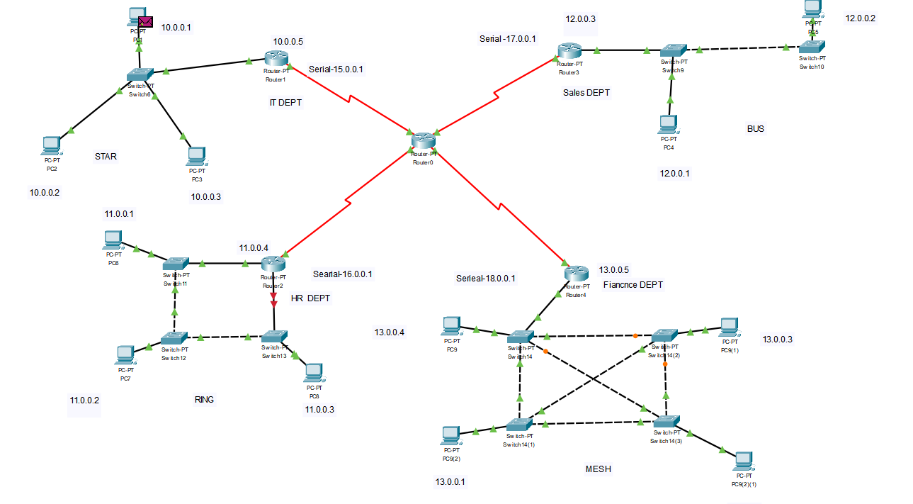
Overall Explanation of the Network Topology
In this network, we have four different departments (IT, HR, Sales, and Finance), each using a distinct Local Area Network (LAN) topology. These departments are connected to a central router, allowing seamless communication across all networks using Routing Information Protocol (RIP).

1. Network Architecture
The network follows a hierarchical topology, where:
- A Central Router acts as the core device, interconnecting all departments.
- Each department has its own router, which manages internal communication.
- Four different LAN topologies are implemented within the departments.
- End devices (computers, printers, etc.) are assigned static IP addresses within their respective subnet.
